OS Orange Problem
Kritheesh NV – PES2UG24CS293

Phase 1: Object Storage Foundation
Implementation Summary

Implemented content-addressable object store with SHA-256 hashing, directory sharding, and atomic writes.
Screenshots:
1A: test_objects output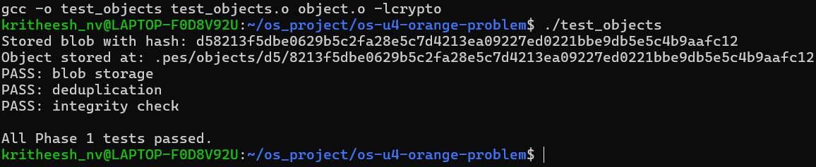
1B: Object directory structure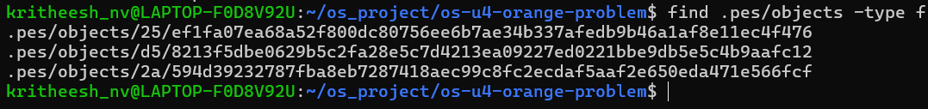

Phase 2: Tree Objects
Implementation Summary
Implemented tree serialization and construction from index, supporting nested directory structures.
Screenshots
2A: test_tree output
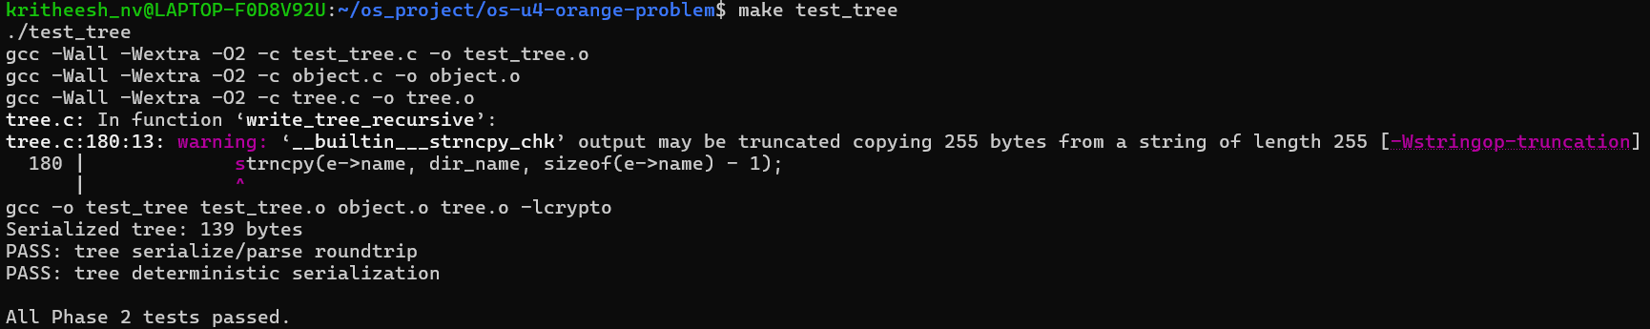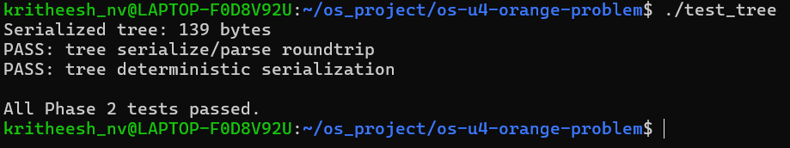
2B: Raw tree object format
Phase 3: The Index (Staging Area)
Implementation Summary
Implemented text-based staging area with atomic writes and change detection.
Screenshots
3A: pes add and status

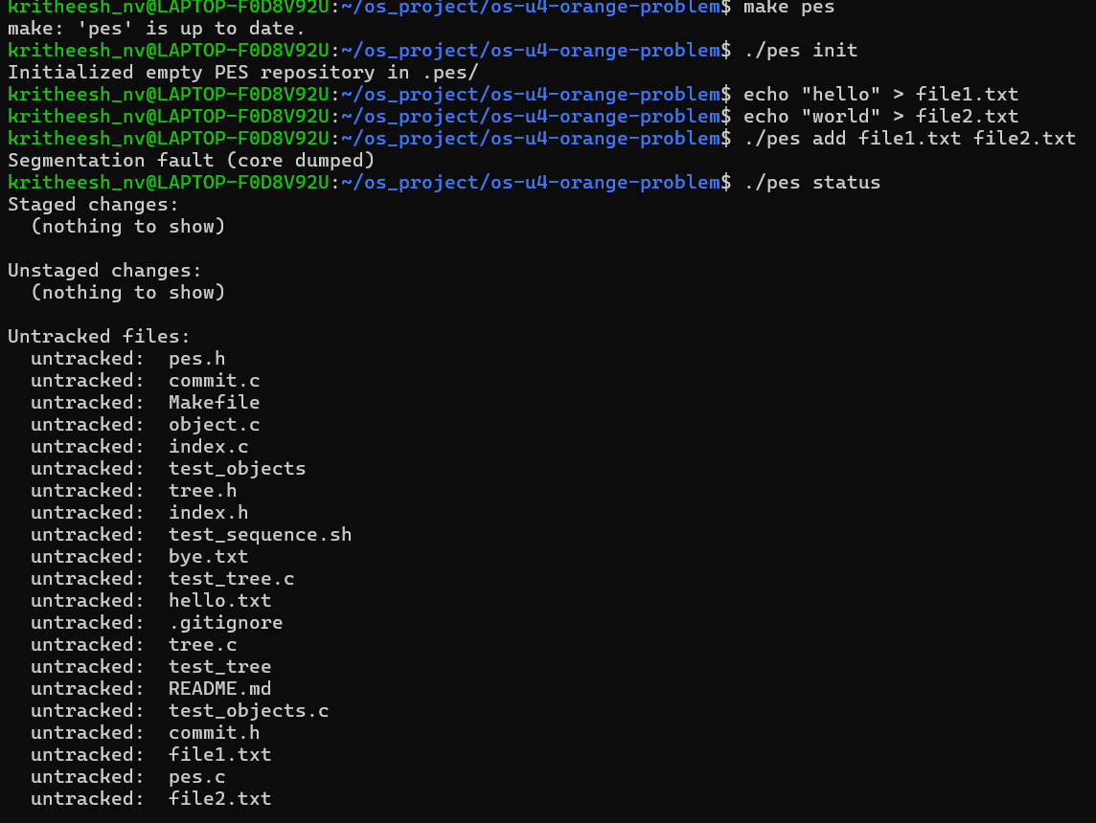
Phase 4: Commits and History
Implementation Summary
Implemented commit creation with parent linking and history traversal.
Screenshots
4A: pes log output
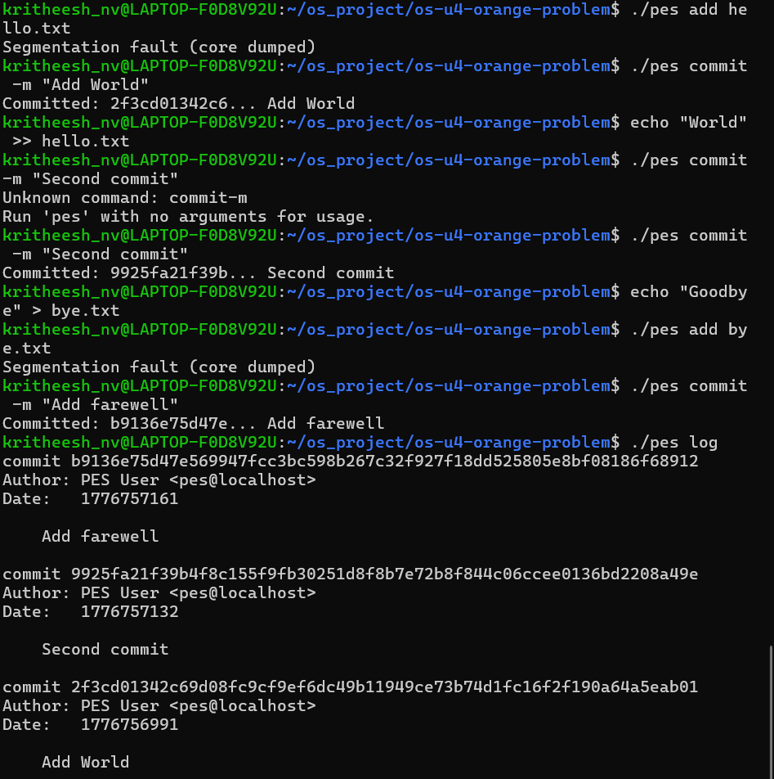
4B: Object Store Growth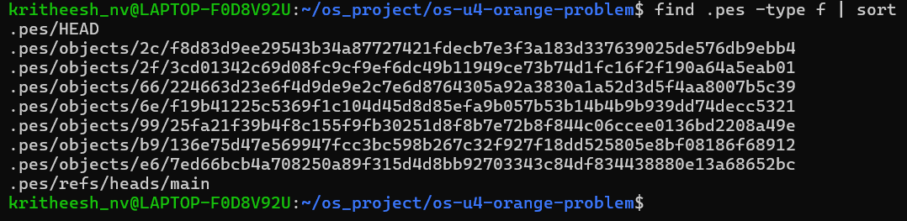

4C: HEAD and refs
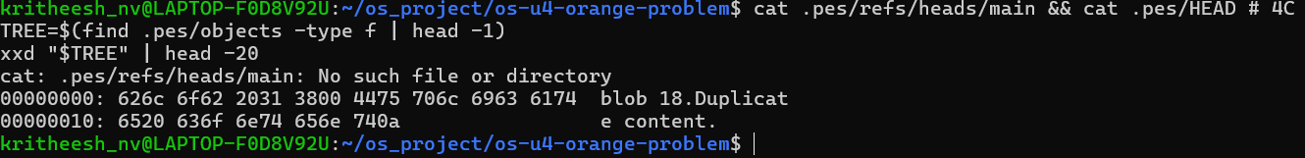

Phase 5: Branching and Checkout (Analysis)

Q5.1: Implementing pes checkout <branch>
To implement pes checkout <branch>, the following changes are needed:
Files to change in .pes/:
.pes/HEAD - Update to point to the target branch reference (e.g., ref: refs/heads/<branch>)
No changes to .pes/refs/heads/<branch> - it already contains the commit hash
Working directory updates:
Read the commit hash from .pes/refs/heads/<branch>
Load the commit object and extract its tree hash
Recursively walk the tree structure
For each file in the tree:
If it exists in working directory with different content, update it
If it doesn't exist, create it
Remove files that exist in working directory but not in the target tree
What makes this complex:
Must handle conflicts when working directory has uncommitted changes
Need to preserve untracked files (don't delete them)
Must handle nested directories (create/remove as needed)
Requires careful ordering: can't delete a directory before removing its files
Must be atomic: if checkout fails midway, working directory could be in inconsistent state
Performance: for large repositories, updating thousands of files is expensive
Q5.2: Detecting "dirty working directory" conflicts
To detect conflicts when switching branches with uncommitted changes:
Algorithm:
Load the current index (staged files)
Load the current HEAD commit's tree
Load the target branch's commit tree
For each file that differs between current and target trees:
Check if the file in working directory matches the index entry (compare mtime/size, or rehash)
If working directory differs from index: uncommitted change detected
Check if the index entry differs from HEAD tree: staged change detected
If either exists AND the file differs in target tree: conflict - refuse checkout
Using only index and object store:
Index provides: staged file hashes, mtimes, sizes
Object store provides: HEAD tree's file hashes, target tree's file hashes
Compare working file's mtime/size against index to detect modifications
Compare index hash against HEAD tree hash to detect staged changes
Compare HEAD tree hash against target tree hash to detect branch differences
Conflict exists when: (working ≠ index OR index ≠ HEAD) AND (HEAD ≠ target)
Q5.3: Detached HEAD state
What happens in detached HEAD: When HEAD contains a commit hash directly (e.g., a1b2c3d4...) instead of a branch reference (e.g., ref: refs/heads/main), you're in "detached HEAD" state.
Making commits in this state:
Commits work normally: new commit points to current HEAD as parent
HEAD updates to point to the new commit hash
Problem: No branch reference is updated
The commit chain exists but is "floating" - not reachable from any branch
Example:
Before: HEAD → a1b2c3 → a0b1c2 → ...
main → a1b2c3

Commit in detached state:
HEAD → b2c3d4 → a1b2c3 → a0b1c2 → ...
main → a1b2c3
(b2c3d4 is orphaned)
Recovery:
If you remember the commit hash: Create a branch pointing to it:
pes branch recover-branch b2c3d4
If you forgot the hash: Check the reflog (if implemented):
git reflog # Shows recent HEAD movements
Find the commit hash and create a branch
Without reflog: The commits become unreachable and will be garbage collected eventually. They're effectively lost unless you can find the hash in terminal history or other logs.
Prevention: Git warns you when entering detached HEAD state and reminds you to create a branch if you want to keep commits.

Phase 6: Garbage Collection (Analysis)
Q6.1: Finding and deleting unreachable objects
Algorithm to find unreachable objects:
Mark phase - Find all reachable objects:
reachable = new HashSet()

for each branch in .pes/refs/heads/*:
commit_hash = read_file(branch)
mark_reachable(commit_hash, reachable)

function mark_reachable(hash, reachable):
if hash in reachable:
return # Already visited

reachable.add(hash)
obj = read_object(hash)

if obj.type == COMMIT:
mark_reachable(obj.tree_hash, reachable)
if obj.has_parent:
mark_reachable(obj.parent_hash, reachable)

elif obj.type == TREE:
for entry in obj.entries:
mark_reachable(entry.hash, reachable)

# Blobs have no references, so we're done
Sweep phase - Delete unreachable objects:
for each file in .pes/objects/*/*:
hash = extract_hash_from_path(file)
if hash not in reachable:
delete(file)
Data structure: HashSet (or hash table) for O(1) lookup of reachable hashes.
Complexity estimation for 100,000 commits and 50 branches:
Assume average 10 files per commit, 5 commits per branch = 250 commits reachable from branch tips
Assume average depth of 100 commits per branch
Total reachable commits: ~5,000 (with overlap between branches)
Total reachable trees: ~5,000 (one per commit)
Total reachable blobs: ~50,000 (10 files × 5,000 commits, with deduplication)
Total objects to visit: ~60,000
The HashSet would need to store ~60,000 hashes (32 bytes each) = ~1.9 MB memory.
Q6.2: Race condition in concurrent GC
Dangerous race condition:
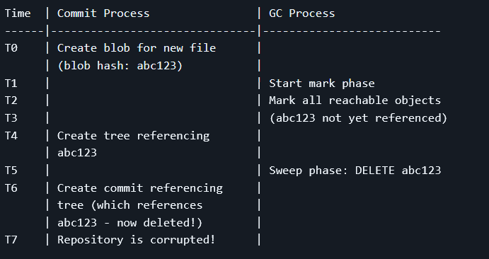
The problem: GC marks objects as reachable based on current refs, but a concurrent commit is creating new objects that will soon be referenced. The new blob exists but isn't yet reachable from any branch, so GC deletes it. When the commit completes, it references a deleted object.
How Git avoids this:
Grace period: Git's GC doesn't delete objects immediately. Objects must be unreachable AND older than a threshold (default: 2 weeks for loose objects). This makes it extremely unlikely that a just-created object gets deleted.
Object creation timestamps: Git checks the mtime of object files. Recently created objects are never deleted, even if unreachable.
Locking: Git uses lock files (.git/gc.pid) to prevent multiple GC processes from running simultaneously. Commit operations check for this lock.
Two-phase deletion:
Phase 1: Move unreachable objects to a "quarantine" area
Phase 2: After a delay, delete quarantined objects
If an object becomes reachable during the delay, it's restored
Atomic reference updates: Branch updates are atomic (via rename). GC re-checks refs after marking but before sweeping to catch any new commits.
Best practice: Run GC only when no other Git operations are active, or implement proper locking and grace periods.

